Week 25.-29.5.
- Revision of vocabulary (opakování slovíček)
https://learningapps.org/display?v=pfn5hfnck20
https://learningapps.org/display?v=pkj340igk20
https://learningapps.org/display?v=p3ro1686520

- Where can you find these things? Write whole sentences. Use prepositions on/in/under. (Kde najdeš předměty z rámečku? Piš celé věty. Použij předložky na/v/pod)
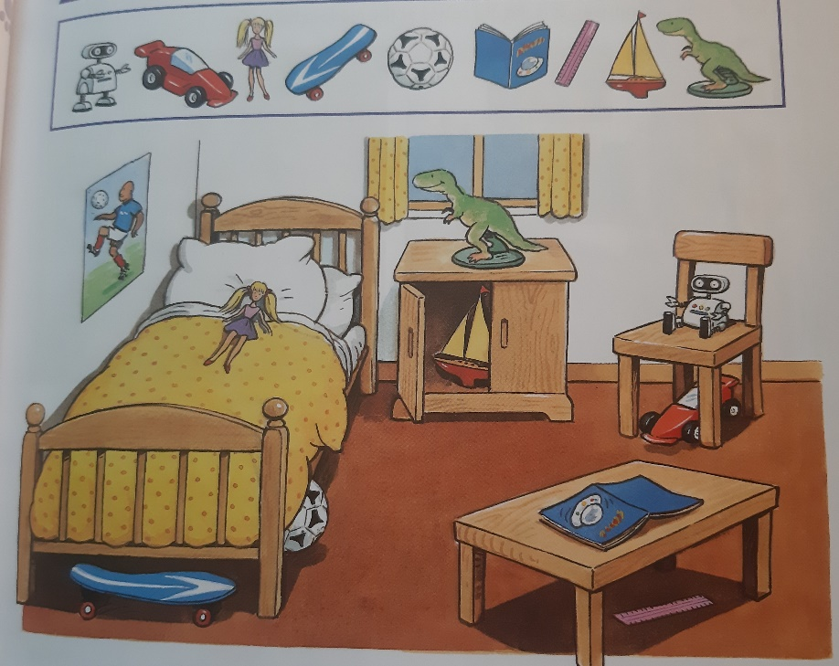
  - A robot is on a chair.
  - A car is……………………………………..
  - A doll ……………………………………….
  - A skateboard………………………………………..
  - A ………………………………………………………….
  - ………………………………………………………….
  - ………………………………………………………….
  - ………………………………………………………….
  - ………………………………………………………….

